**Assignment 15.4**

**Problem Statement:**

Build and Deploy Hadoop word count program using Maven.

**Solution:**

* **Maven installation:**

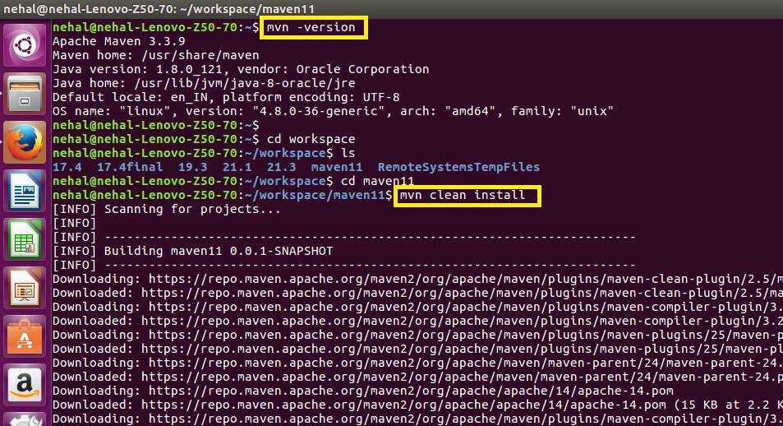

* **Maven project built successfully:**

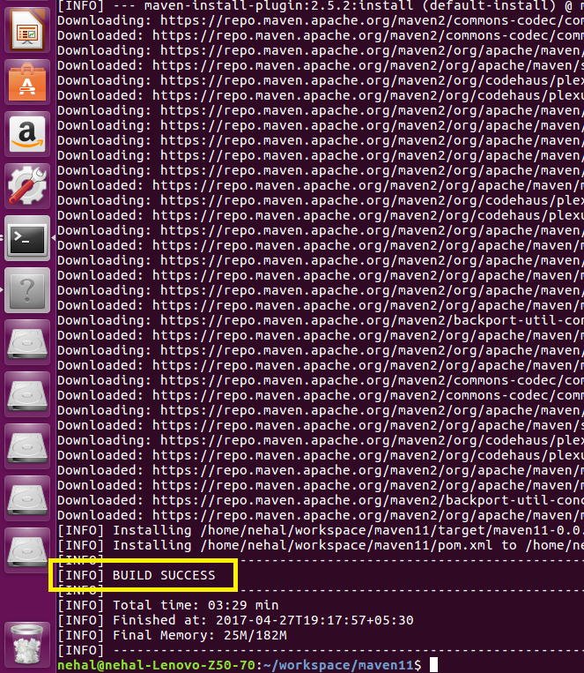

* **Java code for word count:**

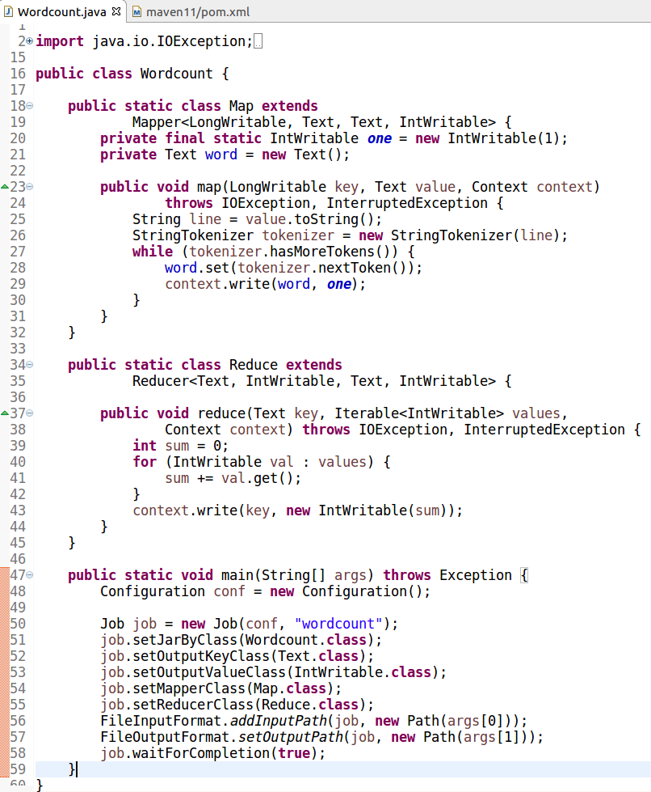

* **Pom.xml file:**

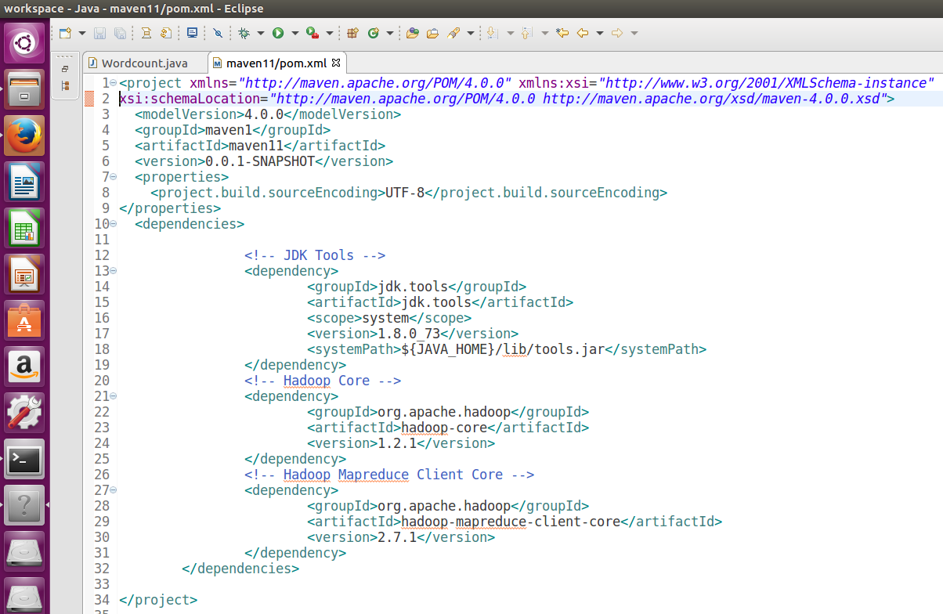

* **Running maven project (jar file):**

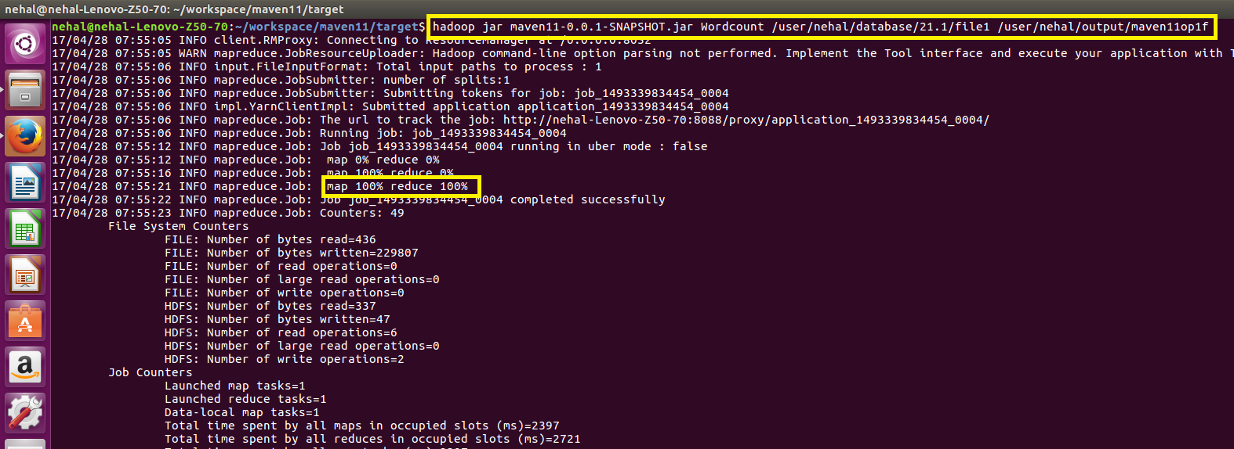

* **Output:**

